SET TAYO NG DATE
Use Case Specification

Submitted to:

Asst. Prof. Ma. Rowena C. Solamo
Faculty Member
Department of Computer Science
College of Engineering
University of the Philippines, Diliman

Submitted by:
Bandong, Arvin
Bariring, Edward James
Rosales, Kyle

In partial fulfillment of academic requirements
for the course
CS 191 Software Engineering I
of the
1st Semester, AY <2016-2017>
Unique Reference:
The documents are stored in the https://github.com/DarkPotatoKing/cs-191-192-repo
File can be found in https://github.com/DarkPotatoKing/cs-191-192-repo/tree/master/01-Project%20Documents

Document Purpose:
This document aims to provide information for each use case that the software will encounter while executing.

Target Audience:
Target audience of this document is the development team, client and other people interested to know what will the software do on specific events.

Revision Control

History Revision:
Revision Date | Person Responsible | Version  Number | Modification
09/24/16 | Edward James Bariring | 1.0 | Initial Document

Use-Case Name: 1.0 User provides input data

Description: User provides his/her free schedule which will be the core component of the software. This includes which day(s) the specific schedule are applicable.

Preconditions: NONE

Flow of Events:
Scenario Name | Description
Scenario 1 (Basic Flow)  Applicant is assigned to the training squad. | 1. Selection committee gets application form.  2. Club staff prepares try-out area.  3. Selection committee evaluates applicant's performance in mock try-outs.  4. If applicant needs training, he is assigned to the training squad.  5. Club staff keeps the application forms in the appropriate files.
Scenario 2  Applicant is assigned to the competing squad. | 1. Selection committee gets application form.  2. Club staff prepares try-out area.  3. Selection committee evaluates applicant's performance in mock try-outs.  4. If applicant plays excellent, he is assigned to the competing squad.  5. Club staff keeps the application forms in the appropriate files.

Activity Diagram of the Flow of Events:
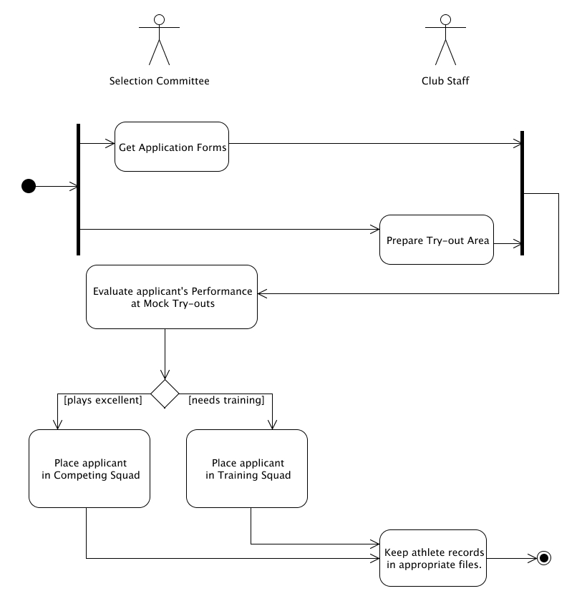

Place here the activity diagram. Make sure that the diagram is grouped as one and text does not wrap around the diagram.

Postcondition: [If there are any, write them here. Otherwise, type in NONE.]

Relationships: [If there are any, write them here. Otherwise, type in NONE.]

Special Requirements:
[If there are any, write them here. Otherwise, type in NONE.]

